UACS User Manual

###### Universal Astronaut and Cargo System (UACS) is a free, open-source astronaut and cargo management system for the Orbiter space simulator.

## Features

* Feature-rich API for vessels, astronauts, and cargoes to integrate within UACS.
* Detailed astronaut implementation, with an optional realism mode to adjust astronaut movement based on gravity acceleration, a powerful HUD to fully control the astronaut, and very customizable config file without writing any code.
* Customizable cargo implementation with a robust config file to accommodate many types of cargoes without any custom coding.
* Detailed manual and API reference.

## Installation

Unzip the archive directly into the Orbiter installation folder, then open Orbiter and open one of the default scenarios to explore UACS. Check the Moon base scenario!

## Overview

###### Core

The core is where all the actual logic exists. It links all UACS parts and allows them to communicate together.

###### API

The API allows developers to interact with UACS system as vessel that hosts cargoes and astronauts using Vessel interface, a cargo using Cargo interface, or an astronaut using Astronaut interface. All API calls are redirected to the core, which performs the necessary operations.

###### Stations

Stations are normal Orbiter vessels that can provide breathable habitat for astronauts, unlimited resources for other vessels, or both, without having to implement UACS vessel API. Any Orbiter vessel can become a UACS station by adding an attachment point in its vessel configuration file.

###### Astronaut

Astronauts are defined by name, role, mass, suit mass, fuel and oxygen level, life flag, and vessel module (be it UACS module or a custom one). They can be created by vessels or scenario editor.

For an astronaut to be addable in the scenario by vessels, its config file must be in ‘Config\Vessels\UACS\Astronauts’ folder even if it’s a custom astronaut module, as this is where the available astronaut list is generated from. Otherwise, the astronaut can only be added using scenario editor or by manually modifying the scenario file.

To support astronauts, a vessel must define at least one airlock and one station. Airlocks are where astronauts ingress into the vessel, and stations are where they sit inside. A vessel can have multiple stations and one airlock, and vice versa.

A station is defined by its name. An airlock is defined by name, position, and optionally a docking port, which can be used to transfer astronauts to another vessel.

To ingress into a vessel, the astronaut must be within a 10-meter radius of the airlock. When the astronaut ingresses, the astronaut information is stored in the vessel, and the astronaut is deleted. Astronauts in this in-vessel state are not Orbiter vessels that exist in the scenario, but merely information stored in the vessel. They are only visible to the vessel they are in and can’t be controlled by the player. When the scenario is saved, their information is saved as a part of the vessel information.

When an astronaut egresses from the vessel, its module vessel is created and its information is passed into it. In this out-vessel state, astronauts are standalone Orbiter vessels, can be controlled by the player, and visible to all vessels in the scenario. Their information is saved normally like any other vessel when the scenario is saved.

A vessel can transfer its astronauts to another vessel if both vessels are docked, and have airlocks associated with the docking port they’re docked with. The astronaut information is simply moved to the other vessel.

###### Cargo

Cargoes are always standalone Orbiter vessels, regardless of whether they are grappled or released. They are managed using attachment points. Packed cargo size is universal: 1.3m x 1.3m x 1.3m cube.

There are 2 cargo types: static and unpackable. Static cargoes are containers that cannot be packed or unpacked. It can optionally contain a resource for vessels to drain from.

Unpackable cargo can be unpacked manually by vessels, or automatically when released, after a period from release, or when landed. If the cargo is grappled while the unpacking timer is running, the timer is reset.

Cargoes can either be unpacked for one time only and cannot be packed again, or unpacked and packed multiple times. Unpacked cargoes have the ability to contain a resource or be a breathable habitat for astronauts.

For a cargo to be addable in the scenario by vessels, its config file must be in ‘Config\Vessels\UACS\Cargoes’ folder even if it’s a custom cargo module, as this is where the available cargo list is generated from. Otherwise, the cargo can only be added using scenario editor or by manually modifying the scenario file.

To support cargo, vessels must define one slot at least. A slot is essentially an attachment point managed by UACS for various cargo operations.

###### Vessel

The vessel part contains the default implementation of the API. Astronauts and cargoes are configurable with config file without writing any code, which allows users to create highly customizable astronauts and cargoes without writing any code or interreacting with API directly.

If the user needs to make a custom astronaut or cargo that is not achievable using config files, the user can interact with the API directly and create a custom astronaut or cargo. Check the developers’ section in this manual.

The rest of this manual discusses UACS default implementations. For custom implementations, refer to their own manuals.

## Carrier

UACS Carrier is a vessel based on Orbiter default ShuttlePB that implements UACS Vessel API. It serves as a showcase for the API capabilities, and a lightweight astronaut and cargo carrier.

Only UACS implementation is discussed here, as the normal vessel specifications are the same as the default ShuttlePB, except for the docking port, which was moved to be at the vessel’s belly.

The Carrier can carry one astronaut in one station, and it has one airlock at the front end, and one slot to carry a single cargo at the top.

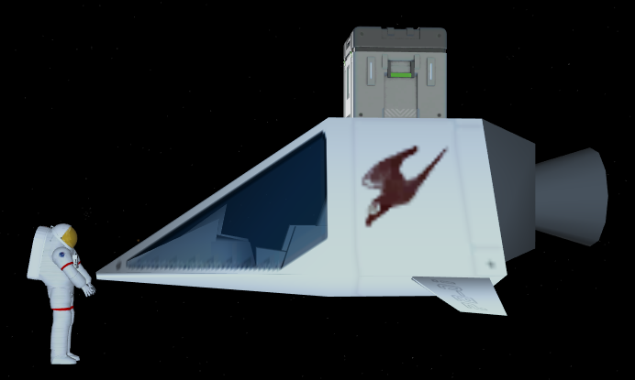

All operations are controlled by keyboard shortcuts and HUD. There are 3 custom HUD modes: Off, Operations, and Shortcuts (displays available shortcuts). These modes overlay on top of Orbiter’s default HUD modes, so both can be used simultaneously.

Operations shortcuts are usable only when Operations HUD mode is active, but they can be used with internal (cockpit) or external camera. Generic shortcuts are always usable regardless of the HUD mode or camera position.

Generic shortcuts

|  |  |
| --- | --- |
| Shortcut | Action |
| Alt + M | Cycle between custom HUD modes. |

###### Operations HUD

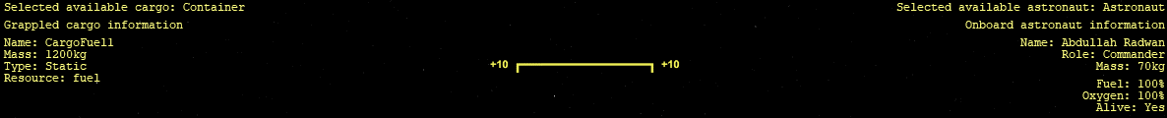

Cargo information is displayed on the left side of the HUD. Shortcuts are displayed, followed by selected cargo to add, an operation result message (displayed for 5 seconds after the operation), and grappled cargo information (displayed only if there is a grappled cargo).

Cargoes can be grappled within a 50-meter radius around the Carrier. Ungrappled cargoes can be packed and unpacked within that radius as well.

In space, cargoes are released upwards with 0.05 m/s velocity. On ground, it’s released in columns and rows on the left side of the Carrier.

To fill up the Carrier fuel tank, the fuel will be drained from the following sources, in order:

1. Grappled cargo.
2. Nearest resource cargo.
3. Nearest UACS station.

The amount of fuel required to fill the tank will be drained. Nearest cargo and station will be searched within a 100-meter radius.

Astronaut information is displayed on the right side of the HUD. As with cargo, shortcuts are displayed, followed by selected astronaut to add, an operation result message (displayed for 5 seconds after the operation), and onboard astronaut information (displayed only if there is an astronaut onboard).

The available astronaut list is generated from ‘Config\Vessels\UACS\Astronauts’ folder. Astronauts are added as in-vessel astronauts, so the station must be empty.

In space, astronauts are egressed directly in front of the Carrier with no relative velocity. On ground, they’re released on the right side.

To transfer an astronaut to another vessel, dock the Carrier (docking port located at belly) with a suitable docking port on the other vessel. An airlock must be associated with the docking port to be able to transfer.

Operations HUD shortcuts

|  |  |  |  |
| --- | --- | --- | --- |
| **Shortcut** | **Action** | **Shortcut** | **Action** |
| **Alt + Numpad 6/4** | Select next/previous available cargo. | Left Alt + A | Add selected cargo. |
| **Left Alt + G** | Grapple nearest cargo. | Left Alt + R | Release grappled cargo. |
| **Left Alt + P** | Pack nearest packable cargo. | Left Alt + U | Unpack nearest unpackable cargo. |
| **Left Alt + F** | Drain resource from nearest source. | Left Alt + D | Delete grappled cargo. |
| **Alt + Numpad 8/2** | Select next/previous available astronaut. | Right Alt + A | Add selected astronaut. |
| **Right Alt + E** | Egress onboard astronaut. | Right Alt + T | Transfer onboard astronaut. |
| **Right Alt + D** | Delete onboard astronaut. |

## Astronaut

UACS default astronaut implementation is highly detailed and thorough. It’s highly customizable using configuration files and features a movements model based on gravitational acceleration, fully functional HUD interface with navigation and operations capabilities, oxygen consumption model based on movements, headlights, and more.

It has 2 tanks: fuel (for RCS) and oxygen. By default, the oxygen lasts for approximately 29 hours when idle, and 2 hours when walking at maximum speed. Both tanks’ capacity can be modified by config files.

The astronaut has one cargo slot in front of its hand. It can grapple unpacked cargoes, which isn’t possible with normal vessels.

There are 2 headlights in the default mesh to provide illumination during night operations. The headlight count, position, and direction can be modified as well.

The astronaut suit provides protection against external environments. It can’t be removed in high or low temperatures and atmospheric pressures. The astronaut can still grapple cargoes and function normally without a suit in a breathable habitat. For the astronaut not to die, it must be within the breathable habitat radius. Astronauts are always egressed with the suit worn.

The enhanced movements model is optional and can be toggled from UACS global config file. It affects astronaut movements on ground, by changing astronaut linear and steering acceleration, and maximum speed based on the distance walked by astronaut in a run.

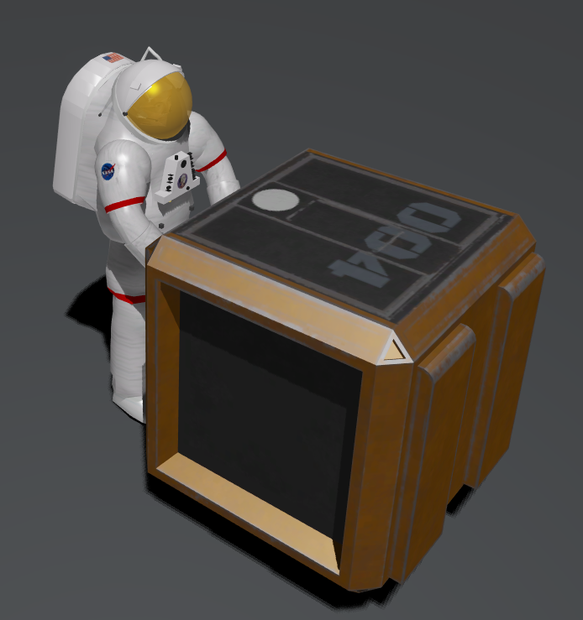

The HUD interface displays basic astronaut information and allows the astronaut to perform all operations using keyboard shortcuts.

There are 6 custom HUD modes: Nearest, Vessel, Astronaut, Cargo, Shortcuts 1, and Shortcuts 2. These modes overlay on top of Orbiter’s default HUD modes, so both can be used simultaneously. Oxygen level and duration are always displayed whenever HUD is turned on, regardless of the HUD mode.

Each HUD mode has its own shortcuts which are only available in that HUD mode. Some of these shortcuts can only be used when the HUD is displayed (i.e., can’t be used from external view or when HUD is turned off). There are generic shortcuts that can be used in every mode and from any view.

Generic shortcuts (*: Press Ctrl for fine control)

|  |  |  |  |
| --- | --- | --- | --- |
| **Shortcut** | **Action** | **Shortcut** | **Action** |
| **Alt + M** | Cycle between custom HUD modes. | Numpad 8/2* | Move forward/backward. |
| **Alt + S** | Toggle suit. | Numpad 6/4* | Turn right/left. |
| **Alt + L** | Toggle headlights. | Numpad 3/1* | Move right/left. |

###### Nearest HUD

Nearest HUD mode displays the navigation information to the nearest open airlock and breathable station or cargo within a 60 km radius by default. It can be modified in UACS global config file.

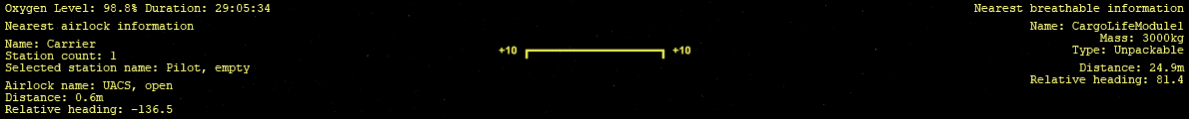

For nearest airlock, the HUD displays information about the nearest airlock with the ability to select which station to ingress to, and whether the station is occupied or not.

On ground, the HUD displays the relative heading. In space, it displays relative yaw and pitch. Positive is up/right, negative is down/left. Align yaw first before pitch in space.

For nearest breathable, cargo information is displayed if the nearest breathable is a cargo. For stations, only name and navigation information are displayed.

Nearest HUD shortcuts(Usable only when HUD is displayed)

|  |  |  |  |
| --- | --- | --- | --- |
| Shortcut | Action | Shortcut | Action |
| Alt + Numpad 8/2 | Select next/previous station. | **Alt + I** | Ingress into selected station. |

###### Vessel HUD

Vessel HUD mode displays the navigation information to a selectable vessel in the scenario.

If the vessel has stations and airlocks, they can be selected to ingress into. It shows whether the station/airlock is occupied/closed or not.

Vessel HUD shortcuts (Usable only when HUD is displayed)

|  |  |  |  |
| --- | --- | --- | --- |
| Shortcut | Action | Shortcut | Action |
| Alt + Numpad 6/4 | Select next/previous vessel. | **Alt + Numpad 3/1** | Select next/previous airlock. |
| Alt + Numpad 8/2 | Select next/previous station. | **Alt + I** | Ingress into selected station. |

###### *Astronaut HUD*

Astronaut HUD mode displays the navigation information to a selectable astronaut in the scenario. Astronaut information is displayed as well.



Astronaut HUD shortcuts (Usable only when HUD is displayed)

|  |  |
| --- | --- |
| **Shortcut** | **Action** |
| **Alt + Numpad 6/4** | Select next/previous astronaut. |

###### Cargo HUD

Cargo HUD mode displays the navigation information to a selectable cargo in the scenario, along with its information on the left side. Only free (ungrappled) cargoes can be selected.

If a cargo is grappled, its information is displayed on the right side.

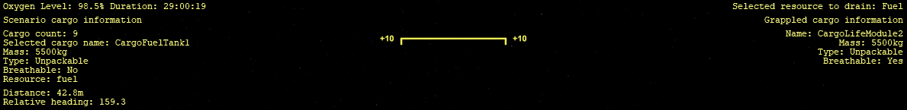

New cargoes can be selected from the available cargo list and added to the cargo slot.

The astronaut can grapple, pack, unpack, and drain fuel and oxygen from the nearest or selected cargo, depending on the shortcut used. Grappled cargoes are released directly in front of the astronaut on ground, and with no relative velocity in space.

Cargo HUD shortcut (*: Usable only when HUD is displayed)

|  |  |  |  |
| --- | --- | --- | --- |
| Shortcut | Action | Shortcut | Action |
| Alt + Numpad 6/4* | Select next/previous cargo. | **Alt + T** | Select resource to drain. |
| Alt + R | Release grappled cargo. | **Alt + D** | Delete grappled cargo. |
| Alt + G | Grapple nearest cargo. | **Ctrl + Alt + G\*** | Grapple selected cargo. |
| Alt + P | Pack nearest packable cargo. | **Ctrl + Alt + P\*** | Pack selected cargo. |
| Alt + U | Unpack nearest unpackable cargo. | **Ctrl + Alt + U\*** | Unpack selected cargo. |
| Alt + F | Drain resource from nearest source. | **Ctrl + Alt + F\*** | Drain resource from selected cargo. |

###### Configuration

Open the config file ‘Config\UACS.cfg’ with a text editor and change the options as required. Astronaut options are located at the top.

|  |  |  |  |
| --- | --- | --- | --- |
| Option | Description | Valid Values | Default Value |
| EnhancedMovements | Enable the astronaut enhanced movements mode. In this mode, astronaut movement on ground are based on the surface gravitational acceleration. | TRUE  FALSE | TRUE |
| NearestSearchRange | The search range for the nearest airlocks and breathable habitats in meters. | Float | 60000 |

## Cargo

UACS default cargo implementation is highly detailed and customizable by config files.

There are 2 cargo types: static and unpackable. Static cargoes are containers that cannot be packed or unpacked. It can optionally contain a resource for vessels to drain from.

Unpackable cargo can be unpacked by vessels. It can either be unpacked for one time only and cannot be packed again, or unpacked and packed multiple times. These can be unpacked to a UACS breathable, resource, or static module, or to an independent Orbiter vessel.

All packed cargoes must have a universal size: a 1.3m x 1.3m x 1.3m cube.

Cargoes don’t have input focus by default (i.e., cargo cockpit can be entered, and the cargo is shown in ‘F3 Select spacecraft’ window). This can be changed in UACS global config file.

Cargoes config files are located at ‘Config\Vessels\UACS\Cargoes’. There are 7 default cargoes: Flags, Fuel Container, Fuel Tank, Life Module, Solar Panels, and Table and Chairs, and Carrier.

###### Flags (FlagXXX)

There are flags for 7 countries: US, Russia, European Union, China, India, Japan, and Egypt.

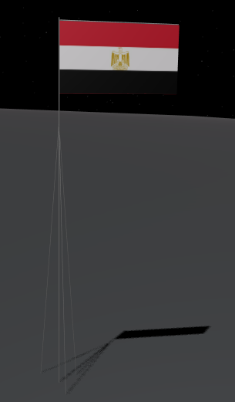

The flag mass is 50 kg and the container mass is 50 kg, so the total mass for a packed flag is 100 kg. Flags can be unpacked and packed multiple times. The flag total size is 1.12m x 0.41m x 3m.

New flags can be created by changing the flag texture. Check the developer manual.

###### Fuel Container

The fuel container contains 1000 kg of fuel, and the container mass is 200 kg, so the total mass is 1200 kg. It’s a static cargo, so it can’t be unpacked or packed.

###### Fuel Tank

The fuel tank contains 5000 kg of fuel, with a container mass of 500 kg and a tank mass of 500 kg, so the total packed mass is 6000 kg. It can be unpacked only once to be a fuel tank. The tank size is 4.5m x 2.3m x 2.6 m.

###### Life Module

The life module provides a breathable habitat for astronauts. Its mass is 3000 kg, and the container mass is 200 kg. It can be unpacked and packed multiple times. The module size is 13m x 9m x 5 m.

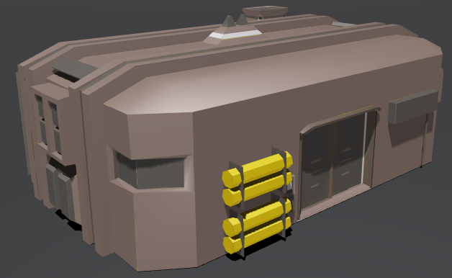

###### Solar Panels

When unpacked, it spawns 5 solar panels, each weighing 100 kg. The container mass is 100 kg, so the total packed mass is 600 kg. Once unpacked, it can’t be packed again. Each solar panel size is 6m x 1m x 0.84 m.

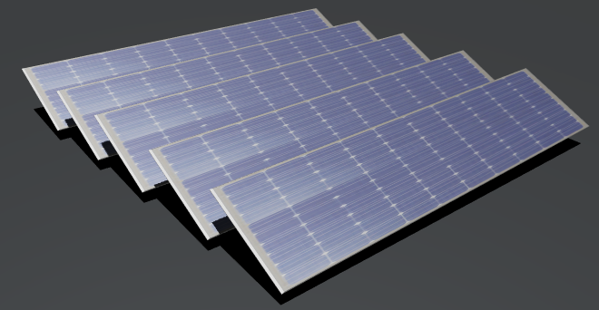

###### Table and Chairs

A wooden table with 4 chairs for a good lunch in space! Its mass is 155 kg, and the container mass is 85 kg. The size is 1.5m x 1.68 m x 1.2 m.

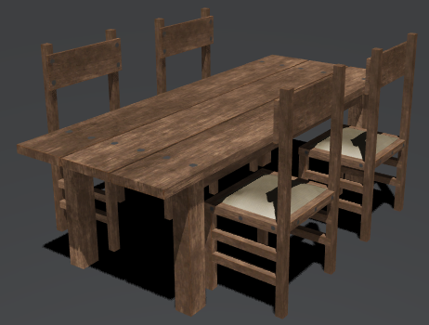

###### Carrier

When released, it spawns a UACS carrier after 25 seconds. It can be unpacked manually in this time frame. It has a mass of 1250 kg and a container mass of 100 kg.

###### Configuration

Open the config file ‘Config\UACS.cfg’ with a text editor and change the options as required. Cargo options are located at the bottom.

|  |  |  |  |
| --- | --- | --- | --- |
| Option | Description | Valid Values | Default Value |
| EnableFocus | Enable the cargo input focus (i.e., cargo cockpit can be entered and shown in ‘F3 Select spacecraft’ window). | TRUE  FALSE | FALSE |

## About

UACS is free and open source under the GPLv3 license. The source code can be found in the [UACS GitHub repository](https://github.com/abdullah-radwan/UACS). All contributions are appreciated.

Copyright © [Abdullah Radwan](mailto:abbodmar@gmail.com)